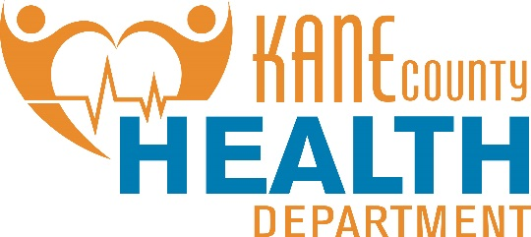

August 19, 2019  
Contact: Susan Stack 630-444-3098  
KaneHealth.com

**Kane County Health Department Announces Annual Well and Septic Seminar**

Well and/or septic systems can be a bit of a mystery to most homeowners. If you need to know how these systems work and how to care for them, plan to attend Kane County Health Department’s annual free Well and Septic Seminar. The event will be held Wednesday, September 18, 2019 at the University of Illinois Extension Office, 535 S. Randall Road, in St. Charles. Due to the popularity of the seminars in the past, two sessions have been added to accommodate demand, at 2 p.m. and 6 p.m. The presentation will be followed by a short question and answer session.

Space is limited. Please call ahead and reserve a seat at 630-444-3040. If you reach the voicemail, please leave your name, phone number, address, email, mention the well and septic seminar and which session you would like to attend, and you will be added to the list.

In addition, one water sample test kit will be given to each household that is supported by well water free of charge.

For more information about well and septic systems, visit the Kane County Health Department’s website at KaneHealth.com/Pages/Water-Waste.aspx

# # #